A. Identify the optimization problem in the given scenario.
Minimize total monthly cargo transportation costs from Amazon’s two air hubs and three focus cities to 68 fulfillment centers worldwide while ensuring that: All centers' cargo demand is met. No hub or focus city exceeds its monthly capacity. Only valid routes with known costs are used.
B. Create mathematical representations of the components of the optimization problem you identified.
1. Write an expression that represents the objective function.
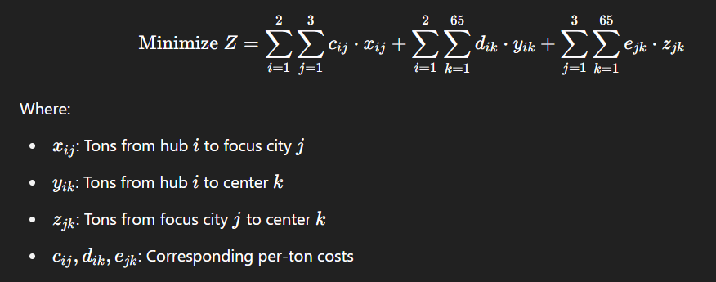
2. Write expressions that represent the constraints of the optimization problem.
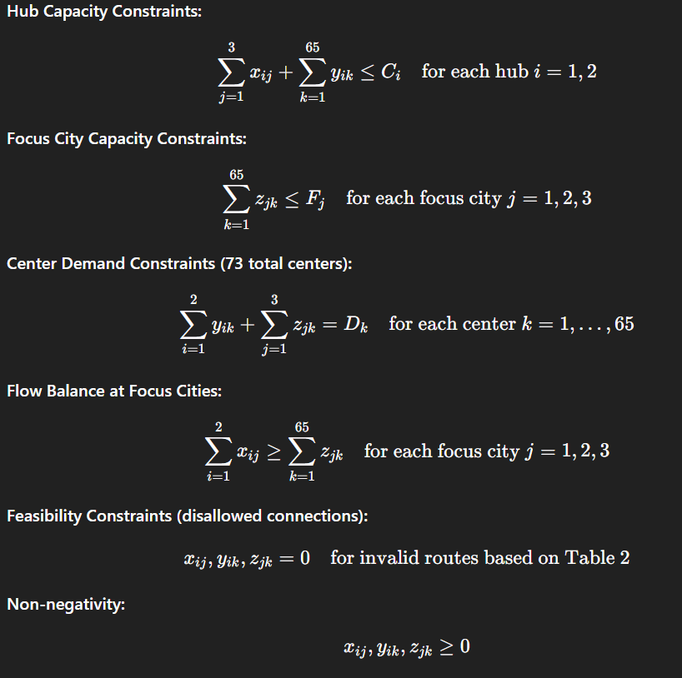
3. Identify the decision variables of the optimization problem.
Variable | Description | From → To
xijx_{ij} | Tons from hub to focus city | Hub ii → Focus city jj
yiky_{ik} | Tons from hub to center | Hub ii → Center kk
zjkz_{jk} | Tons from focus city to center | Focus city jj → Center kk

C. Describe the approach you will use to solve the optimization.
1. Identify the optimization method or algorithm you will use to solve the problem.

This is a Linear Programming problem: The objective function and all constraints are linear.

2. Describe the tools and technologies you will use to solve the problem.
Python for LP formulation and Plp library

D. Assess the risks and limitations involved in your recommended optimization approach.
For data quality, inaccuracies in cost or capacity figures can significantly impact outcomes. Some unmodeled constraints like real-world operational factors like flight schedules, weather delays, geopolitical issues aren't captured. Scalability: As the network grows, LP solvers may need high-performance environments to remain efficient.

E. Acknowledge sources, using in-text citations and references, for content that is quoted, paraphrased, or summarized.

F. Demonstrate professional communication in the content and presentation of your submission.

